PRODUCT RECORD COMPONENT: Workspace Existing

1. Component Details
Component Name: Workspaces
Document Owner: Loren
Dev Leading: N/A
Last Updated: May 21st, 2026
Status: Assigned for Validation by QA
Component Epic Jira:
SPX-5910: Workspaces - Component Record
Component Filtered Search backlog of tasks & Bugs:
https://specterx.atlassian.net/issues?jql=project%20%3D%20%22SPX%22%20AND%20component%20%3D%20%22Workspaces%22%20AND%20status%20NOT%20IN%20(Done%2C%20Canceled) - Can’t find link
Existing Behavior Record (Workspace 1.0): PRODUCT RECORD COMPONENT: Workspace Existing (Requires QA Validation)

2. Behavior

2.1 Overview
SpecterX Workspaces provide a lightweight, structured environment for two-way file exchange with internal and external users. A Workspace serves as a governed container where participants can upload files, access files permitted by policy, and perform allowed file actions under a primary parent policy.
A Workspace is created by a licensed Collaborator and contains a member list, assigned roles, a parent policy, and a set of contributed files. Workspaces function as controlled environments: every file uploaded into a Workspace inherits the Workspace’s parent policy, Workspace Owners manage membership and settings, and the Workspace enforces a consistent protection model across all content.
Workspaces support structured intake of external files, secure file delivery, and ongoing file exchange where centralized policy and auditability are required. Workspace owners can manage all files and see all audit logs, data owners that uploaded files to the workspace can see audit logs and delete files they own.
Workspaces does not support file-level policy divergence, or granular permission differences per file.

Workspace Creation
Licensed Users (Collaborators, Admins & Auditors) can create a Workspace via the SpecterX WebUI by selecting “Request Files”.
- “Request Files” is the only route to creating a Workspace prompts for a name and input of recipients to automatically notify
  - The user can create a new Workspace by selecting from a dropdown list of their existing Workspaces, or create a new Workspace.
    - Platform does not enforce unique names.
  - Once named, the Workspace is created automatically with the tenant default policy assignment
    - If the User selects to cancel the “Request Files” flow or navigates away from the flow before adding recipients, the Workspace is created without recipients, showing the Workspace
    - Platform does not support creation of provisioning of Workspace without recipients as a direct flow
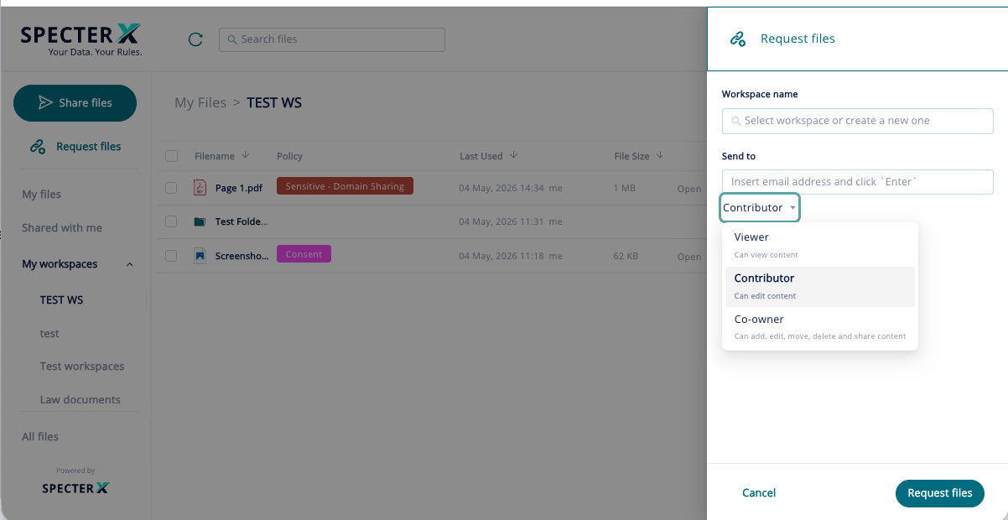

Parent Policy Enforcement
- All uploaded files inherit the Workspace’s parent policy.
- Parent policy is assigned to all uploads into the Workspace
- UI allows file-level policy modification after upload, but changes do not persist and revert to parent policy when Workspace is accessed by new recipients.
- When the parent policy changes, all existing files adopt the parent policy when a new member accesses the Workspace.

Workspace Membership/Access
- Workspace Access is viewed through the Permissions Draw and shows only those provisioned at the Workspace level
  - If additional users have access to files within the Workspace, this is not exposed within Workspace level permissions
- Workspace owners cannot revoke access of data owners at the file level
- Workspace and data owners cannot remove access to files if the user has access at the Workspace level
  - UI will allow the user to complete the access revocation flow but wont take action in the backend of create logs

Workspaces Roles
Roles include: Owner, Co-Owner, Viewer or Contributor
Assumed behavior (pending confirmation):
- Workspace Owners
  - Can manage the parent policy of the Workspace
  - Can view all audit logs of all files within the Workspace
  - Can delete any/all files within the Workspace, including files owned by others within the Workspace
  - Can add new members at the Workspace level
  - Can add new recipients to any file within a Workspace (?)
  - Can change the user role of members of the Workspace to:
    - Contributor
    - Viewer
    - Co-owner
- Workspace Co-Owners
  - Have all the functions provided to Workspace Owners except:
    - Co-owners do not get notifications related to Workspace activity (See notifications section for details)
  - Can be assigned to licensed and unlicensed users
- Workspace members assigned as Contributor
  - Can upload files to the Workspace
  - Can see audit logs of files they have uploaded to the Workspace
    - Cannot see logs of files they did not upload
    - From Audit Logs, can see all members of the Workspace (Assuming because they will see permission added for their files)
  - Can delete files that they have uploaded to the Workspace
  - Can add recipients (that do not belong to the Workspace) if the Workspace Policy supports forwarding
- Workspace members assigned as Viewer:
  - Can see all files within the Workspace
  - Cannot upload files to the Workspace
  - Can add recipients (that do not belong to the Workspace) if the Workspace Policy supports forwarding
  - Cannot see Workspace logs
Regardless of role assignment and workspace ownership, files uploaded are owned by the Uploader.

File Deletion Behavior
- Files deleted from the Workspace are deleted from the Platform
- Owners/Co-Owners may delete any file.
- Recipients can delete files they have uploaded
- Platform provides the ability for recipients to delete all files if the recipient uses the ‘select all’
  - The platform will delete the files that recipient has uploaded, but will not delete files that user did not upload
- Workspace Owners or Data Owners do not receive notifications when files are deleted from the Workspace.
- When file retention is triggered due to policy, both files and the Workspace are deleted from the Platform

Group Behavior
- A Workspace can be shared with a Group with data role of Viewer, Contributor, or Co-owner assigned at the Group Level
- Platform does allow users to be added as recipients by individual email address even if they are already provisioned access at the Group level
  - Platform presents that individual users access to the Workspace can be revoked while access is still provided via the Group Access
  - Platform supports individual users role can be assigned separately from the Group Level role assignment
    - Group Role assignment appears to be the overriding role assignment
- Visibility into members of the group is not supported from the Workspace permissions list
  - This list is only available to admins with User & Group management panes
- Logs show permission added to the group by Group name not by individual members
- If password or phone number details are missing for any member of the group, sharing to the Group cannot be completed
  - This is shown to the user for detail input in the moment of sharing

QA please clarify:
- If policy is changed to a policy that requires phone number and SMS and some details are missing for a group that is already provisioned with access, are just those with missing details within the group prevented from accessing files or is the entire group blocked (as they are with initial share when some details are missing)?

Notifications
- There are 3 Notifications Types specific to Workspace:
  - “User” invites you to Share Files with them
  - “User” tried to access [Workspace name] and was blocked
  - “User” added files to [Workspace name]
- Notifications arrives from Notifications@specterX.com
- Workspace Owners receive notifications upon file upload by members.
  - Co-owners do not
- No notification when the Workspace is accessed, only when files are downloaded or Opened
- Workspace Owners/Co-Owners will not receive notification if recipients delete files
- Workspace Owners receive notifications when a user attempts to access a Workspace in that they are not provisioned access for

Notification: Invitation to join the Workspace
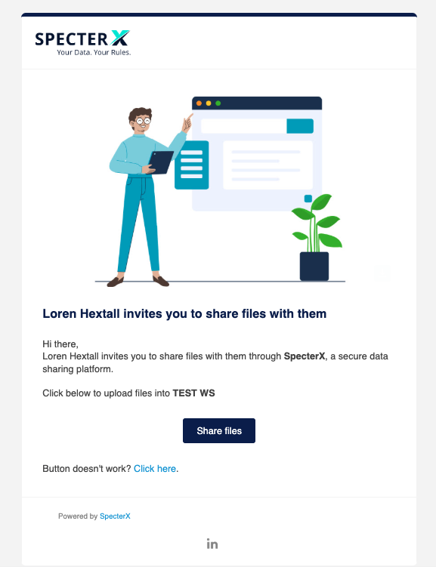
- This notification is used when an empty Workspace is shared and when a Workspace containing Files is shared with a user, regardless of role assignment
  - Recipients assigned as Viewer cannot upload files but Notification call to action is prompting for file upload

Notification: Attempted Access to Workspace Blocked
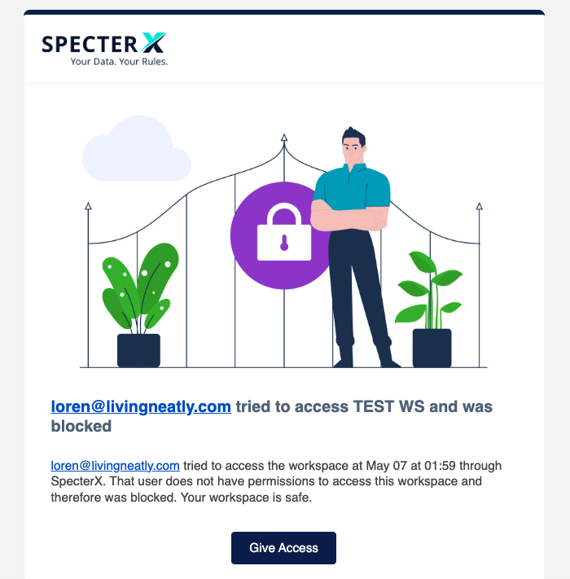
- Delivers to Workspace owner when a user attempts to access a Workspace without access
- To be validated by QA:
  - If a protected download owned by a user other than the Workspace owner attempts to access an AIP protected file and is blocked, will the file owner receive the access notification?

Notification: User added files to Workspace
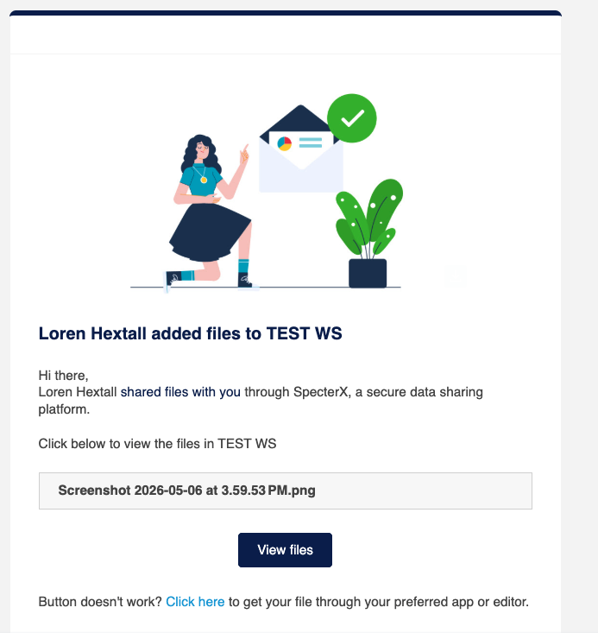
- QA please validate:
  - Is this notification only provided to the Workspace Owner?
    - Asking because it is strange that it doesn’t specify that the files were added to your workspace and because reads as if this would be a notification that we would send to an external user by the way SpecterX is introduced

Notification: Folder within a Workspace Shared
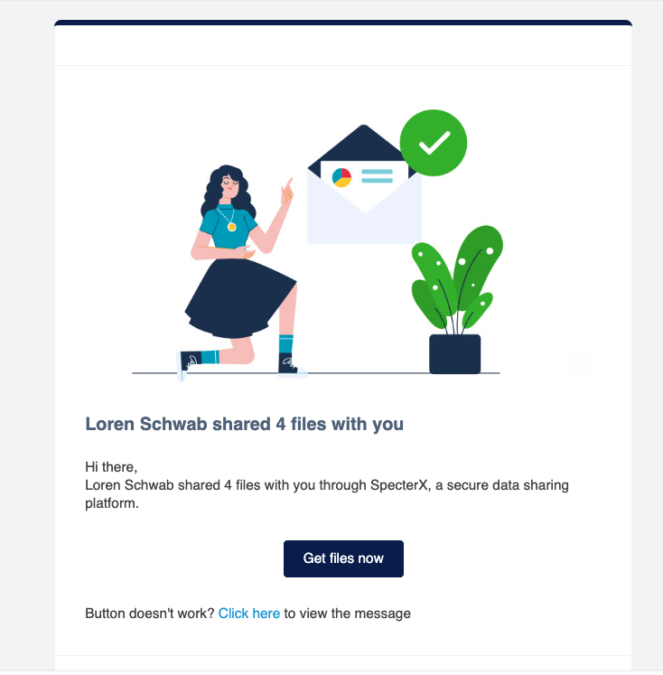
- Content shared from within a Workspace is delivered with the standard file share Notification
  - Notification appears from the user that initiated the Share, not the data owner
  - If the recipient uploads a file to this folder via the send file back flow, the file will be uploaded to the Workspace

4. Known Conflicts with AIP

4.1 Re-upload of Previously Encrypted Files into an IRM Workspace
A Workspace enforces its parent policy at the point of file upload. The upload path does not distinguish between newly introduced files and files that were previously protected by SpecterX.
When a file that is already encrypted (via SpecterX IRM or password protection) is uploaded into a Workspace governed by an encryption parent policy, the system treats the file as a new upload and attempts to apply encryption again.
Resulting Behavior
The upload fails due to re-encryption, even if the file originated from the same Workspace earlier in its lifecycle.
Why this matters
From a user perspective, downloading a file for editing and re-uploading it to the same Workspace is a reasonable expectation. From the system’s perspective, upload enforcement is stateless with respect to prior file protection.

4.2 IRM Enforcement Persistence When Uploading into a Non-IRM Workspace
File-level enforcement may persist across lifecycle events, independent of the Workspace’s parent policy. The system does not currently reconcile prior enforcement state with the policy context of a new Workspace.
When a file previously governed by an IRM policy is uploaded into a Workspace governed by a non-IRM parent policy:
- The system does not recognize the file as a returning, previously protected artifact.
- The UI reflects the Workspace’s parent policy and identifies the uploader as the Data Owner.
- Backend enforcement continues to apply the original IRM policy.
Resulting Effect
The re-uploader appears to own the file and manage its policy, but is effectively only the uploader. Policy changes made in the Workspace do not influence access or enforcement, and recipients may be denied access despite UI indications to the contrary.
Why this matters
This creates a divergence between perceived ownership and effective control, driven by lifecycle-based enforcement that is not surfaced or reconciled at upload time.

5. Known Limitations of Platform Governance Rules
Workspace enforcement of Platform Governance Rules are not enforced although audit logs show Share Evaluation Request operation.

6. QA Validated Existing Bugs
This section should be updated with known behavioral bugs (short hand) and should reflect the pruned bug list within Jira.

